**SUMMER INTERNSHIP AT BHARAT HEAVY ELECTRICALS LTD**

A Summer Internship Report Submitted in Partial Fulfillment of the Requirements for the Award of the Degree of

**BACHELOR OF ENGINEERING**

**IN**

**ELECTRICAL AND ELECTRONICS ENGINEERING**

By

**PATTA MANGATHAYRU MAHITHA(160721734014)**

Under the Esteemed Guidance of

**Dr. Ramesh Babu (Associate Professor)**



**Department of Electrical & Electronics Engineering**

**METHODIST COLLEGE OF ENGINEERING AND TECHNOLOGY**

**(An Autonomous Institution, affiliated to Osmania University & Approved by AICTE, Accredited by NAAC with A+ and NBA)**

**King Koti, Abids, Hyderabad, Telangana – 500001**



**Department of Electrical and Electronics**



This is to certify that the “Internship Report” submitted by PATTA MANGATHAYRU MAHITHA, Roll No: 160721734014 is submitted during 2023– 2024 academic year, in partial fulfillment of the requirements for the award of the degree of BACHELOR OF ENGINEERING in Electrical and Electronics Engineering, at BHEL.

Mr. J. RAMESH BABU Mrs. Y. MASTANAMMA

Associate Professor Associate Professor

Internship Coordinator Head of the department

**CONTENTS**

**1. ABOUT BHELHYDERABAD……………………………………………………………………...02**

**2. DESCRIPTION OF ELCTRCAL MACHINES FEATURES …………………………………....03**

**3. VARIOUS SHOP FLOOR ACTIVITIES IN EM (02), BHEL HYD……………………………..14**

**4. TG STATOR MANUFACTURING PROCESS……………………………………………..……..26**

**5. CONCLUSION………………………………………………………………………………………..27**

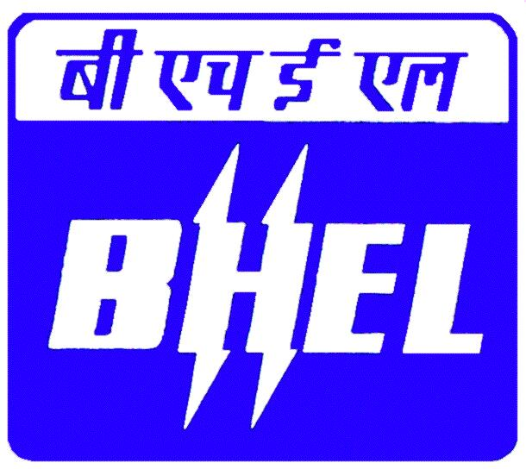

**BHEL AT RAMACHANDRAPURAM**

A vital link of chain of BHEL manufacturing units is a unit at Ramachandrapuram; Hyderabad. BHEL Hyderabad manufactures Turbo Generators of 1.5MW to 120MW capacities. They will be manufactured according to the customer requirement.

These turbo-generators are supplied together with turbines and matching excitation systems and are used mostly in paper, sugar, cement, petrochemicals, fertilizers etc., and thermal power stations. The turbo generators are based on the proven design know how backed by over 3 decades of experience gained by BHEL.

There are nine important products are manufactured at Ramachandrapuram.

1. Gas turbines

2. Steam Turbines

3. Compressors

4. Generators and Exciters

5. Heat exchangers

6. Pumps

7. Pulverizes

8. Oil Field Equipments

9. Switch gear/circuit breakers

BHEL has borrowed technology for manufacturing generators from SKODA Exports Czechoslovakia in 1960's they borrowed from M/s. **Siemens, Germany** and it's sister company **KWU(KraftWerk Union)** in Germany. They borrowed less than 12 modules, from semen's Germany. Till now the BHEL has developed more than 70 modules on their own.

The turbo generators are based on proven designs and know how backed by over 3 decades of experiences gained by BHEL engineers in this field keeping pace with the latest development in insulation systems to optimize the design. BHEL Hyderabad is the only one in Asia that has the latest type of insulation system called the Vacuum Pressure Impregnation System.

SPECIAL FEATURES OF THE TURBO GENERATORS DESIGNED BY BHEL

1. High output to weight ratio

2. Thermo setting class F epoxy insulation both resin rich and micalastic vacuum impregnation.

3. Low loss high-grade silicon steel for laminations.

4. Optimally designed fans on the rotors.

5. Better voltage waveform with less harmonic content.

6. Low wind age loosed and low noise.

7. Static/blushless excitation.

8. Split casing design for low manufacturing cycle for VPI design.

###### 

###### ELECTRICAL MACHINES

Machine acts as a generator converts the mechanical energy into electrical energy. The machine, which acts as a motor, converts electrical energy into mechanical energy

The basic principle of rotating machine remains the same i.e.

**“ FARADAY’S LAWS OF ELECTRO MAGNETIC INDUCTION”.**

Faraday’s first law states that whenever conductor cuts magnetic flux, dynamically induced EMF is produced. This EMF causes a current flow if the circuit is closed.

Faraday’s second law states that EMF induced in it, is proportional to rate of change of flux.

e = -N dφ/dt

EMF induced will oppose both the flux and the rate of change of flux.

In the case of AC generators the armature winding is acts as stator and the field winding acts as rotor.

Efficiency of a machine is equal to the ratio of output to input

η = Output / input = Output / output + losses

To increase the efficiency of any machine we must decrease the losses, but losses are inevitable. There are different types of losses that occur in a generator.

They are broadly divided into 2 types

(1) **Constant losses**

(a) Iron losses

(b) Friction and windage losses (air friction losses).

(2) **Variable losses**

(a) Copper losses

Electrical machines are of two types. AC machines & DC machines. AC machines are divided into single-phase AC machines and polyphase AC machines

3 Phase AC machines are divided into

|  |  |  |
| --- | --- | --- |
| 1 | ***SYNCHRONOUS MACHINES***: | |
|  |  | Synchronous Generators (or) Alternators are those in which the speed of the rotor and flux are in synchronism |
| 2 | **ASYNCHRONOUS MACHINES**: | |
|  |  | These are the machines in which the flux speed and rotor speed will not be the same. |

Ex: Induction motors.

Inherently all the machines are AC machines. AC or DC depends upon the flow of current in the external circuit.

Synchronous generators can be classified into various types based on the medium used for generation.

1. Turbo-Alternators Steam (or) Gas

2. Hydro generators

3. Engine driven generators

In every machine they are two parts

* Flux carrying parts
* Load carrying parts

In large synchronous machines the stator have the load carrying parts, i.e. armature and the rotor has the flux carrying parts i.e.; field winding.

Iron losses are also called as magnetic losses and core losses. They are broadly divided into

1. Hystersis losses
2. Eddy current losses

These losses occur in the stator core.

Copper losses occur in both stator and rotor winding.

The general efficiency of a synchronous generator is 95-98%

The main parts in a synchronous-generator are:

STATOR, ROTOR, EXCITATION SYSTEM, COOLING SYSTEM, INSULATION SYSTEM, BEARINGS.

**ELECTRICAL MACHINES:**

GENERATORS (1 MW to 250 MW)

EXCITERS (Matching to Generators upto 250 MW)

**Generators:**

H2 COOLED 3000 RPM STG (up to 250 MW)

AIR COOLED GENERATORS (1 MW to 150 MW) 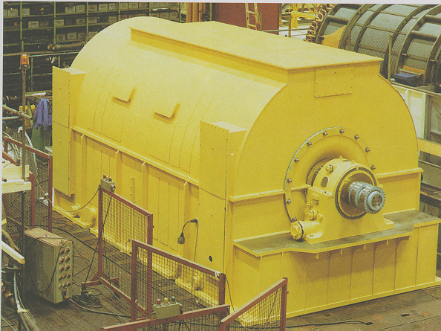

**2- Pole Generators**

STG (18 MW to 250MW)

GTG (FR 5 to FR9FA)

**4- Pole Generators**

STG (1- 30 MW)

GTG (FR1,3 & 5)

*Classification of Synchronous Generators*

* TYPE OF PRIME MOVER GT/ST
* TYPE OF CONSTRUCTION 2-POLE/ 4-POLE
* FREQUENCY 50 / 60 Hz
* COOLING MEDIUM AIR/ HYDROGEN
* TYPE OF COOLING OPEN AIR/ CACW

**Type of Prime Mover:**

Gas Turbine

Steam Turbine

Gas Turbine

*Closed Circuit Air Cooled*

Coolers on Top

Coolers on Side

Open Air Cooled

Terminals on Side/Top

Outdoor/Indoor Installation

**Steam Turbine**

Coolers Below/Side of the M/C

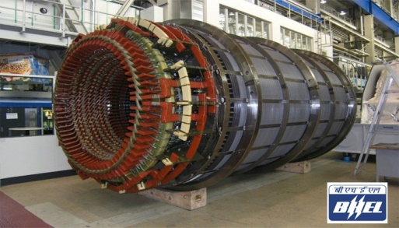

Terminals from Bottom/Side

Indoor Installation

## **Type of Construction:**

## Synchronous Generator

Round Rotor

Salient Pole Rotor

**Round Rotor**

Solid Rotor

Laminated Rotor

**Salient Pole Rotor**

Solid Pole

Laminated Pole

**Type of Cooling:**

Air Cooled

Hydrogen Cooled

Air Cooled

Open air cooled

Closed circuit air cooled

Closed Circuit Air Cooled

Coolers on Top

Coolers on Side

Coolers below the M/C

##### Generators Manufactured At BHEL, Hyderabad

* Continuous improvement and up gradation of design features
* Overhang type brushless exciters
* Terminal box option up to 40 MW
* µ-processor based numerical protection system
* Digital AVR
* High degree of standardization of components based on modular concept.

### **Characteristics of VPI Insulation**

* Higher mechanical bond
* Void-free insulation
* High dielectric strength, low dissipation factor and hence longer electrical life
* Better heat transfer
* Higher thermal stability, ensures Class-F in running condition
* Less maintenance
* Cost effective

#### Advantages of Global Impregnation

* Heat transfer coefficient is better
* Void free insulation
* Non-hygroscopic
* Less volume for given output
* Lower life time cost

##### Salient Features of 2 Pole Generators

* Collaborator : Siemens, Germany
* Range : 18 MW To 250 MW; 6.6, 11.0,13.8 & 15.0 KV
* Insulation type : Micalastic with Global Vacuum Pressure Impregnation
* No. of machines manufactured : approx. 300
* Compact size, cost effective
* Less manufacturing cycle
* Terminals at top or side for GTG and at bottom for STG
* Bar windings with 3600 transposition to reduce eddy current losses
* Solid rotor forging of Cr Ni Mo V alloy steel
* Silver bearing semi hard electrolytic copper conductor for rotor winding
* Half coil technology for rotor winding to achieve better forming and consolidation of end winding
* Slot wedges of good electrical conductivity shorted at the end by retaining rings
* 18 Mn 18 Cr retaining rings of forged non-magnetic steel shrunk fitted on the rotor barrel
* 2 Nos. of axial fans mounted on each side of rotor for ventilation of Generator with screwing type individual fan blades
* 2 nos. of journal bearings with one insulated to eliminate bearing currents
* RTDs for temperature measurement of stator winding and core.
* Central cooling technology for uniform cooling of the stator core and windings
* Advanced four flute cooling for rotor giving improved cooling effect

###### 4 POLE GENERATORS AT BHEL, HYDERABAD

* Collaborator : Siemens, Germany
* Range : 3 MW To 30 MW; 3.3, 6.6, 11 kV
* Insulation Type : Micalastic with Global Vacuum Pressure Impregnation
* No. of machines manufactured : approx. 60
* Multi-turn windings with pulled coil technology for minimum cycle time to manufacture
* Laminated round rotor construction
* Compact size, modular designs which are cost effective
* Less manufacturing cycle
* Terminals at top or side for GTG and at bottom for STG
* 2 Nos. of radial fans mounted on each side of rotor for ventilation of Generator
* 2 nos. of journal bearings with one insulated to eliminate bearing currents
* Total generator can be dispatched as a single package

###### Main Parameters Influencing Design: IMG_256

###### Apparent Power (MVA) / pf

* Active Power (MW)
* Voltage (3.3/6.6/11/13.8 Kv)
* Speed (1500/1800/3000/3600 RPM)
* Drive ( ST / GT / Others)
* Cooling Medium (Air/Hydrogen/Water)
* Type Of Load (Step loads, motor starting etc.)
* System fault levels (Machine reactances)
* Harmonic currents (Thyristor loads)
* V/F variations
* Open/ closed cooling water circuit

## **TECHNICAL DESCRIPTION OF AIR COOLED 2-POLE GENERATORS**

**1.0 INTRODUCTION:**

The synchronous generator is of two poles, 3-phase air cooled type and is designed for continuous operation at its rated output. The constructional features ensure reliability, easy maintenance and economical operation.

**2.0 STATOR:**

**2.1 STATOR FRAME:**

The stator frame is of welded steel construction and supports the laminated core and the winding. The welded circular ribs as well as the axial stiffeners provide the required rigidity for the stator frame.

**2.2 STATOR CORE**:

The stator core is stacked from thin cold rolled non-oriented electromagnetic sheet steel punching’s having low loss factor and high permeability and is suspended in the stator frame from the insulated guide bars. The laminations are slotted, deburred and varnished with high quality synthetic varnish. The core is divided into packets of required dimensions and these packets are separated by radial ducts to provide adequate passage for the flow of coolant. These ducts are formed by insulated thick stamping steel laminations on which ventilating spacers are spot welded. Glass laminate sheets are placed adjacent to each thick lamination sheet of every packet to provide additional insulation. For reducing the stray load losses, the air gap is enlarged at both ends of the core by means of stepped end packets which are glued together to prevent vibration during operation. During the assembly of the core, the laminations are pressed together under heat using a hydraulic press to ensure a rigid and consolidated core and is firmly held together by means of clamping fingers, end plates and non-magnetic through type insulated clamping bolts which are so arranged as to ensure a uniform clamping pressure especially within the teeth area and at the same time providing for uniform intensive cooling of the stator core ends.

**2.3 STATOR WINDING**:

The stator winding is of short chorded pitch, double layer lap-bar type construction. The stator bars are composed of varnished and glass covered copper strips. The strips are stacked to form a Roebel bar with 360 deg. transposition in order to reduce eddy current losses. The stator after placement of coils in the slots is impregnated in VPI system and hot cured thereafter to form a consolidated mass. This ensures excellent electrical and mechanical properties of stator winding. To prevent corona discharges, the bars are wrapped with conductive polyester fleece during insulation of bar stage. The overhang of the winding is supported with resin absorbent glass mats and tyings which ensure a very rigid support after resin absorption and hot curing. Six terminals are brought out of the stator end cover at exciter end.

**3.0 ROTOR**

**3.1 ROTOR SHAFT**:

The rotor shaft is a single piece, solid forging of special Alloy steel manufactured by vacuum casting by reputed shops under strict inspection and control. To ensure that only high quality forgings are used, strength tests, material analysis, and ultrasonic tests are carried out during manufacture. Radial slots are milled axially on the rotor body to accommodate the field windings. The slots are distributed over the circumference so that two solid poles are obtained. After completion, the rotor is balanced thoroughly and subjected to an over-speed test at 120% of the rated speed for 2 minutes.

**3.2 ROTOR WINDINGS**:

The rotor winding consists of several coils made of high conductivity silver bearing electrolytic copper conductors ensuring high thermal stability. Each coil consists of several series connected turns comprising two half turns each of which is connected by brazing in the end winding portions. Slots are punched in the coils to provide ventilation paths. The individual turns of the coil are insulated against each other by epoxy glass laminates. L-shaped slot troughs of epoxy glass cloth with Nomex filler are used as slot insulation. The wedges are made of well conducting material and short-circuited at their ends through the retaining rings which are silver plated at the contact surfaces to act as an effective damper winding.

**3.3 RETAINING RINGS:**

The centrifugal forces of the rotor end windings are taken up by single-piece retaining rings. The retaining rings are forged out of non-magnetic steel in order to reduce stray losses and are cold worked to have high mechanical strength. The forgings are subjected to mechanical tests and non-destructive tests to ensure soundness and high quality. The retaining rings are shrink fitted on the rotor barrel on one side, and on the hubs on the other side. Each retaining ring is secured axially by a snap ring. They are insulated from the rotor winding by high quality insulation of sufficient thickness.

**3.4 FANS**:

The cooling air is circulated by two axial flow fans located on either side of the rotor barrel. The fan blades have threaded roots for being screwed into the rotor shaft. The blades are dying forged from aluminium alloy. Each blade is secured at its root by grub screws against loosening.

**4.0 BEARINGS**:

The generator rotor is supported on two journal bearings. The bearings are lined with Babbitt material to reduce the wear and damages to the journal. To eliminate shaft currents, one bearing is insulated. The bearing temperature is supervised by a thermo-element arranged in the lower half of the bearings, so that the measuring point is located directly below and nearer the Babbitt. Each bearing is provided with facilities for fitting vibration pick-ups for vibration supervision. The oil supply for the bearings is provided from the turbine oil system.

**5.0 VENTILATION**:

The turbo generator is designed with closed circuit forced air cooling system. Radial type of ventilation system is employed in the stator and rotor. The cooling air is passed through the various ventilation paths and the hot air flows out of the stator frame and is cooled in water-air heat exchangers. The air is circulated by the axial fans in the machine.

**6.0 TEMPERATURE\_MEASUREMENTS:**

The temperature at different points in the stator winding, cold air region, hot air region and the generator and exciter bearing metal are measured by means of resistance temperature detectors (R.T.D.s) of Platinum Pt. 100 type, placed at a number of suitable places. This R.T.D.s would be connected to a temperature scanner provided in the generator control panel.

## **TECHNICAL DESCRIPTION OF AIR COOLED 4-POLE GENERATORS**

**1.0 Introduction**

The synchronous generator is of 4-pole, 3-phase air cooled type and is designed for continuous operation at its rated output. The constructional features ensure reliability, easy maintenance and economical operation. The generator is suitable for operation with any of the modern excitation systems.

**2.0 Stator:**

**2.1 Stator Frame:**

The stator frame consists of two end clamping plates with welded-on pressing fingers designed to hold the laminations in position by means of axial ribs welded under pressure at the back of the core and to the clamping plates.

**2.2 Stator Core:**

The stator core made of cold rolled non-grain oriented silicon sheet steel punching having low loss factor and high permeability is stacked between the two end clamping plates. The laminations are slotted, deburred and varnished with high quality synthetic varnish. The core is divided into packets of required dimensions and these packets are separated by radial ducts to provide adequate passage for the flow of cooling air. These ducts are formed by insulated 1mm. thick stamping steel laminations on which ventilating spacers are spot welded.

**2.3 Stator Winding:**

Stator coils are of diamond pulled type with fine mica paper tape insulated copper strips and with ground insulation of resin poor mica paper tapes. This cured insulation has excellent electrical characteristics and provides highly reliable protection against mechanical and atmospheric effects. These coils are inserted into the slots punched in the stator core and the individual coils are joined by brazing. In order to withstand short circuit forces, the winding overhangs are stiffened by spacers between the coil ends and with bandage rings. The whole stator, including the winding will be kept in a tank and immersed in synthetic resin and impregnated under vacuum and pressure. After impregnation it will be cured at a specified temperature in an oven. This process results in extremely good mechanical and electrical strength. The insulation of the winding corresponds to Class 'F'. Three neutral terminals, three phase terminals are brought out on the non-drive end of generator.

**3.0 Rotor:**

**3.1 Rotor Shaft:**

The rotor shaft is forged out of chrome-nickel-molybdenum or equivalent material with the required mechanical and metallurgical properties. The shaft has axial ventilation grooves milled on the barrel surface for supplying the cooling air to the rotor core. An axial bore is made in the exciter side of the shaft for taking the input leads to the field winding through two inclined holes opening into the ventilation grooves at the rotor overhang portion

**3.2 Rotor Core:**

The rotor core is made of low-loss silicon sheet steel laminations of circular shape coated with synthetic varnish. Slots are punched in the stampings for accommodating the windings and damper bars.

The rotor core is divided into small packets by radial ventilation spacers for adequate cooling air passage. Steel clamping plates are used at both ends of the core and the fixing nuts of the tension bolts are welded to these plates after tightening.

**3.3 Rotor Windings:**

The rotor winding consists of single-layer former-wound coils. The coils are of bare silver bearing copper and are inserted into the slots and wedged with Class 'F' insulation. The rotor winding is impregnated with epoxy resin. The damper bars are driven into the slots in the outer periphery of the laminated core and welded to the clamping plate on both sides to form a damper cage. The overhang winding will be protected against the centrifugal forces by glass-fiber banding tapes and held in position by non-magnetic Austenitic steel retaining ring forgings..

**3.4 Fans**:

Two radial-flow fans are mounted on both sides of the rotor to circulate the required cooling air into the machine.

**4.0 Bearings:**

Two radial sleeve bearings are provided to support the rotor. Each bearing essentially consists of the bearing pedestal, sealing rings, split bearing shell, a sight glass for checking the oil level and oil ring. The bearings are provided with ring lubrication in addition to the pressure lubrication. The bearing pedestal is secured to the base frame by means of hexagonal bolts and is located in position after alignment by dowels. The bearing at the non-drive end is insulated from the machine base frame to prevent the flow of shaft currents.

**5.0 Base Frame:**

The base frame is fabricated out of structural steel plates. This is designed to support the generator along with bearings and exciter (in case of brushless exciter) and to withstand short-circuit conditions.

**6.0 Enclosure:**

The enclosure is fabricated out of structural steel material with adequate stiffening and is designed in two parts viz. top part of the enclosure and bottom part of the enclosure. The enclosure rests on the rubber beading on the base frame. The construction of the enclosure is such that it reduces the structure-borne noise to the minimum and provides the required protection to the machine. The design of the enclosure shall suit the ventilation system required for the machine.

**The main parts in a turbo generator are:**

1. Stator.
2. Rotor

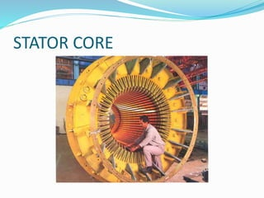

3. Excitation system.

4. Cooling system.

5. Insulation system.

6. Bearings.

7. Protective devices.

**Stator part includes:**

1. Stator frame and encoders.

2. Stator core.

3. Stator bars.

4. Stator windings.

5. Output leads/bushings.

**Rotor parts include:**

1. Rotor body.

2. Rotor winding

3. Rotor shaft.

4. Field connection.

5. Rotor retaining rings.

6. Fans.

7. Journal bearings.

**Excitation system is of 3 types.**

1. DC excitation system.

2. Static excitation system.

3. Brushless excitation system.

**ROTOR**

The rotor consists of the shaft, the rotor core, the field winding, the damper winding, the fans, the slip rings or the rotor of the brush less exciter.

The shaft transmits the torque to the machine. The rotor is carried by two bearings. The field winding is inserted in the slot groups of the rotor core, connected and linked to the terminals of the direct coupled exciter by leads run through the hollow shaft. The bars of the damper winding are driven into the slots at the periphery of the core and are connected to an end disc at either end.

In a turbo generator there are two types of rotor designs.

Forged solid rotor

Laminated rotor

The main function of the rotor is that the rotor acts like an electromagnet by taking currents from the excitation system. It is coupled to the turbine rotor to take the driving torque and thus produce a flux, which leads for the generation of current. The change in the flux produced by the rotor windings induces voltage in the stator winding. It also has to withstand high power torque produced by the turbine and the backward torque produced due to the generator current.

For large capacity machines solid forged rotor is preferred. It is made from vacuum cast steel ingot. About 60% of the rotor body circumference has longitudinal slots which hold the winding.

There are two types of rotors are used in generators.

Salient pole type

Cylindrical pole type

SALIENT (PROJECTING) POLE TYPE:

It is used in low and medium speed (engine driven) generators. It has a large number of projecting poles, having their cores bolted or dovetailed onto a heavy magnetic wheel of cast iron, or steel of good magnetic quality. Such generators are characterized by their large diameters and short axial lengths. The poles and pole shoes are laminated to minimize the heat due to eddy currents. The salient pole synchronous machines have non-uniform air gap between the rotor and the stator. The air gap is minimum under the pole centers and maximum between the poles.

SMOOTH CYLINDRICAL TYPE:

It is used for steam turbine driven i.e. turbo generators, which run at high speeds. The rotor of a two-pole machine is forged taking into account the strength considerations and the speed. In case of the four-pole machine the centrifugal force developed is 1/4 of that of a two pole machine and hence the core of such a turbo generator is laminated. The lamination of the rotor core reduces the losses due to eddy currents. This also provides for a reduction in the cost when compared to the rotor of the two-pole machine. In this type of rotor, the air gap is the same throughout neglecting the slot openings. Generally synchronous machines consist of the high power armature winding on the stator and the low power field winding on the rotor.

ROTOR SHAFT: The shaft of the rotor is forged from vaccum degassed alloy steel to impart required mechanical properties. The rotor is designed to withstand the stress due to centrifugal forces in operation and fatigue due to start and stop operations through out its life. The rotor consists of an electrically active portion called barrel and two shaft ends integrally forged. The rotor of two-pole machine is forged, whereas the rotor of the four-pole machine is a laminated core. Along the core of the rotor, longitudinal slots of rectangular shape are milled to form a cylindrical rotor. At the bottom of the rotor slot is a vent canal to conduct the cooling gas towards the center. The central position of the slot accommodates the winding with insulation and in the top of the slots the wedges are driven to keep the winding against the centrifugal forces. The tapped holes to screw the balancing weights and the moon slots which minimize the double frequency vibrations of the core are machined along the length of the two pole faces. On the turbine side a coupling is shrunk along with a key to give connection to the LP turbine rotor. The central bore in the non-driving end of the shaft houses the field lead, which connects the winding and the slip rings.

The rotating components are attached to the shaft by means of keys or are shrink fit. The shaft is made of alloy steel forging. Shaft is dimensioned as required for the torque to be transmitted, taking into account the stresses occurring during shorting, to ensure that the static deflection is kept to a minimum and that the natural frequency of the critical flexural vibration of the shaft differs sufficiently from the rated speed.

The rotor shaft is a single-piece solid forging manufactured from a vaccum casting. Slots for insertion of the field winding are milled into the rotor body. The longitudinal slots are distributed over the circumference so that two solid poles are obtained.

To ensure that only high quality forgings are used, strength tests, material analysis, and ultrasonic tests are performed during manufactured of the rotor. After completion, the rotor is balanced in various planes at different speeds and then subjected to an over-speed test at 120% of rated speed for two minutes.

FIELD WINDING:

The field winding consists of several series connections of coils inserted into the longitudinal slots of the rotor body. The coils are wound in such a way that the required number of poles is obtained. The individual conductors are made from 0.1% Silver alloyed copper in case of a two-pole machine and Douglas copper in the case of a four pole machine. This silver alloyed copper is bent to form full turns and the continuous turns of slots constitute one coil. The silver alloyed copper as compared to electrolytic copper features very high mechanical strength at elevated temperatures and has more of fatigue and creep resistance and thus eliminates coil deformations due to thermal stresses .The individual conductors are provided with axial slots for radial discharge of cooling gas and all conductors have identical cooling ducts cross sections.

INSULATION:

The individual turns of every coil are insulated by glass fiber laminates with matching ventilating holes. The L shaped strips of glass fiber laminated with Nomex interleaving is used as insulation between the coil and the rotor body. The space between the individual coils and the end winding is filled with insulating members in order to prevent the coil movement under stresses.

RETAINING RINGS:

The concentric shaped overhand of the rotor winding is retained in the place against centrifugal forces by non magnetic cold expanded steel rings called retaining rings. The material of the retaining rings is stress and corrosion resistant. It is cold worked to reduce stray losses. The high quality of the rings is ensuring by the mechanical and nondestructive tests. These rings are shrunk fitted on the steps, machined at the ends of the rotor barrel and are locked against axial movement by a ring nut and four parted arrestment ring. The ring nut is threaded internally and is shrunk fitted on the threads machined on the retaining rings At the other end of the rings , a floating type of the centering ring called hub is fitted. The hub shields the end of the rotor winding and the coolant enters through the annular gap between the shaft and the hub. Thus one ring holds the rotor body while the other holds the overhang. This ensures and unobstructed shaft deflection at the end winding. A snap ring is provided for additional protection against the axial displacement of the retaining rings. The wedges and the retaining constitute the damper circuit of the rotor.

Alloy Steel forging has the following properties.

1. A very high mechanical strength.
2. Non magnetic in nature.

FIELDS CONNECTIONS:

The field’s connections, comprising of connectors, radial bolt and field lead complete the electrical connection between the rotor winding and the slip rings. The field lead consists of two semicircular steel conductors insulated from each other by an intermediate plate and from the shaft by a tube and is located at the central bore of the rotor shaft. The insulated radial steel bolts connect one end of the field lead to the winding and the other end to the slip rings through connectors. Flexible copper connectors are employed at the coil during operation. One end of the connector is brazed to the coil and the other end is fastened to the radial bolt. A t the slip ring end rigid copper connectors, one end bolted to slip rings and the other end to the radial bolts, provide the necessary connection. Rubber gaskets at the radial bolts ensure gas tight sealing and prevent leakage of hydrogen through bolts.

DAMPER WINDINGS:

Most of the generators have their pole shoes slotted for receiving copper bars of a grid or damper winding. The copper bars are short circuited at both ends by heavy copper rings. These dampers are useful in preventing the hunting (momentary

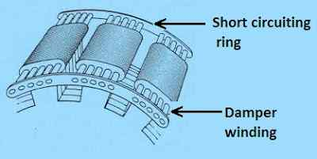

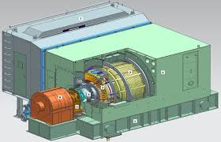

**DETAILED MANUFACTURING PROCESS IN VARIOUS SHP FLOORS IN EM (02)**

**PRESS SHOP (3211):**

1. RECEPTION OF SILICON STEEL ROLLS: - Silicon steel rolls are checked for chemical, mechanical, electrical and magnetic properties as per the specifications. If they are all satisfactory then they are cleared for further operation.
2. BLANKING:-Silicon steel rolls are fed into the cutting machine. it is processed to required shape as per the design requirement.
3. NOTCHING:-Notching is defined as a process of getting the required dimension and required shape. It is of two types COMPOUND and INDIVIDUAL notching.

Compound notching is a means of getting the required dimension of required shape by processing at one stroke. It is carried out in two machines 315 and 500 tonnes M/cs.Individual notching processes sheets individually for individual operations.

1. DEBURRING:-All the laminations are deburred up to 5microns.
2. VARNISHING:-After completion and processing of lamination, the sheets are varnished with 4000 CPV DR-BECK. The thickness of the varnish should be 7-12microns per side.

In order to achieve 7-12microns per side following checks are carried out.

* + Viscosity:-Viscosity of varnish should be maximum for 44secs with a din-4-cup.
  + Adhesiveness:-Pour some xylol on the lamination sheet and wait for 1 min and see that varnish doesn’t dissolve in xylol. This indicates that the varnish is adhesive.
  + Checking of hardness:-The varnished laminations are hit and the varnish should not flake.
  + Insulation resistance measurement:-Stack 20 laminations on hydraulic press with copper conductor at top and bottom. Press 26 kg/cm^2 and check with megger by connecting with copper strips. I.R value should be greater than 1 M ohm.
  + Measurement of coating thickness:-Varnish thickness measured by mini tester should be 7-12microns.
  + Temperature of the furnace:-Temperature should be maintained at 300-400 degrees.

6.CORE ASSEMBLY:-Check the horizontal plate in test pit with spirit level(0)

Place the hydraulic blocks over the horizontal plate as per design requirement. Then place stumbling blocks over the horizontal plate. Place finger plate over stumbling block. Carry out for trial packet assembly. Assembly one trial packet assembly by placing laminations sheets by using mandrills and assembly drifts. After completion of 1 packet check for inside dia with inspection drift. There should be no lamination projections inside or outside slots. Dismantle the trial packet if all the points are met.

Assemble stepped packets over the clamping plates. Place one layer of ventilation lamination. Carry out normal packet assemblies. Assemble 0.5mm lamination segments by forming the required diameter. After completion of 1 packet, assemble 1 layer of ventilation lamination. Over it place 1 layer of HGL. Again place 0.5mm silicon steel laminations up to a thickness of 1packet.By inserting assembly drifts into the slots and mandrills into the holes and check for inside dia and slot freeness with inspection drift. There should be no lamination projections inside or outside slots. Assemble 1more layer of ventilation lamination for normal packet. Over it place 1layer of HGL. Again place 0.5mm silicon steel laminations upto a thickness of 1packet. By inserting assembly drifts into the slots and mandrills into the holes and check for inside dia and slot freeness with inspection drift. There should be no lamination projections inside or outside slots.

7. The above procedure is continued until we obtain 800mm core height. 1st pressing is carried out by giving pressure of 20kg/cm2.Check for core height, inside dia and slot freeness with inspection drift. There should be no lamination projections inside or outside slots. Similarly following the above procedure core height is assembled upto pre final core length by pressing intermittently for every 800mm, until we achieve the final core height. Then pre final pressing is carried out. Check for core height, inside dia and slot freeness with inspection drift. There should be no lamination projections inside or outside slots. If the final height isn’t obtained replenish the laminations in the subsequent final packets.

Assemble the final core assembly .After its completion do final pressing. Assemble top clamping plate and final pressing fixtures. Carry out final pressing by giving the calculated load 20 kg/cm2 for the specified design. Under the load check for core height. If core height is as per the design specification then assemble tension bolts into respective mandrills holes and tighten it by using torque wrenched spanners. Dismantle the assembly fixture and check for inside dia and slot freeness with inspection drift. There should be no lamination projections inside or outside slot. On the top clamping plate assemble winding brackets as per design requirement and welding is carried out. Check for 90 degree. Carry out full welding of each and every bracket and check for die penetration test. Assemble guide bars into respective grooves of laminations. Clamp the bars by bottom half, middle half and top half rings. Half rings are pressed with hydraulic system. All the three rings are compressed with hydraulic press until guide bars are fitted into the dovetail grooves. The welding is carried out from bottom to top clamping plate. After completion carry out D.P test on all the welds. The total core is shifted horizontally by using assembly’s fixtures. Then onto the bottom clamping plate winding brackets are assembled as per design requirement and welding is carried out. Check for 90 degree and D.P test is also conducted. Total core is checked for sharp corners, lamination projections and interruption of foreign matter.

If detected they are rectified. Core is cleaned thoroughly and subjected for core flux test. It is carried out in order to detect hot spots of the core. If no hot spots noticed the Stator core cleared for stator winding.

**COIL SHOP (3215):**

STATOR WINDINGS IN RESIN-POOR PROCESS:

1. RECEPTION OF CONDUCTOR ROLLS: - Conductor rolls are checked for chemical, mechanical, electrical and chemical properties as per the specifications. If they are all satisfactory then they are cleared for further operation.
2. CONDUCTORS CUTTING:-Copper roll is fed into cutting machine. First conductor is checked for drawing specification. Then conductor length is fixed. Stopper is also fixed for specified length. If the length is satisfactory then mass cutting operation is allowed.
3. TRANSPOSITION:-All the required number of conductors is arranged in the given template and the fixtures centre to centre length is checked as per the specifications and the dies are matched properly and then transposition is carried out for first bundle. Similarly it is carried out for second bundle. Now after obtaining 2nd bundle both the bundles are joined together by inserting half insulation (nomex) and tied with cotton tape. The total bundle is the total stator bar.
4. PUTTY OPERATION:-All the uneven surfaces on the width face are filled up with nomex pieces in order to make the bar even and eliminate inter-strip shorts. Mica folium is assembled on the straight (width face) of the bar and tied with PTFE tape.
5. STACK CONSOLIDATION:-After completion of putty operation stator bars are subjected for straight part consolidation by heating upto 140-150 degrees for a duration of 2-3hrs under pressure of 150kg/cm^2 horizontally as well as vertically.
6. DIMENSIONAL CHECK, INTER-STRIP AND INTER-HALF SHORTS DETECTION:-All the bars are checked for dimensions (width and height of the bar) by go and no-go gauges. Inter-strip and Inter-half shorts are detected by 230V lamp test.

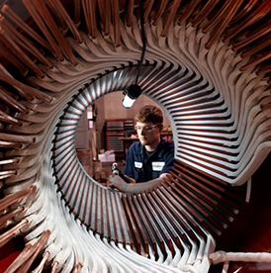

**LIGHT MACHINE SHOP(3212):**

**1 Name**  : Vertical Lathe

**Type**  : SK12

**Specification** : 200 mm dia. Chuck with 3 tool post

**Machine components**  : Bearings rings, retaining rings, Snap rings,

Intermediate rings, Hubs, Yokes,

Rectifier rings, RR wheels, sealing rings,

Clamping Plates

**2. Name** : Vertical Milling Machine

**Type**  : FA5V

**Specification**  : Sleave Borse tapper 50

**Machine components**  : Bearings , Profiles, Grooves,

Step cutting, Depth Cut

**Cutting Tools** : End mill, T-max, Slot Drill bit

**3. Name** – : Centre Lathe

**Type** – : SU 80

**Specification** - : 1M diameter chuck

**Machine Components** : Facing, Planning , Turning,

Step Cutting, Ball forming Grooving,

Thread Cutting

**4. Name** : Radial Drilling Machine

**Type**  : VR8

**Specification**

**Machine Components**  : Drilling, Tapping, Reaming

**5. Name** : Horizontal Milling machine

**Type** : FGS 50

**Specification**  : Spherical diameter for bearing outside

**Machine Components**  : Surfacing, Milling

**COPPER SHOP ( 3214 )**

1. RECEPTION OF COPPER CONDUCTORS: - Copper Conductor are received in rectangular strips and checked for chemical, mechanical, electrical and chemical properties as per the specifications. If they are all satisfactory then they are cleared for further operation.
2. VENTILATION PUNCHING:-Rectangular conductors are fed through a template into a ventilation punching machine to get the desired ventilation holes as per the drawing requirement. Further checking is carried out and random checking is done during processing.
3. CHAMFERING:-All the ventilation holes are punched or chamfered to remove the extra material projected out of the ventilation slot.
4. EDGE-WISE BENDING:-Bending is carried out on the bending machine on both the sides. Dimensions are checked with respect to centre of the conductor and the desired specifications are achieved.
5. ANNEALING:-Annealing is carried out by heating on bend zones on both sides of the conductor at 600 degrees and it is then quenched in water for getting it cooled.
6. CORNER PRESSING:-The conductors are pressed at the corners to normal size by hydraulic press and it is checked for dimensions with gauges.
7. 90 DEGREES RECTIFICATION:-All the conductors are rectified for 90 degrees on bending table and checked for 90 degrees from centre of conductor on both the sides.
8. DOVE-TAIL PUNCHING:-Conductors are processed for male and female joints by punching in a dove tail machine. After processing all the conductors for 1 set of coil,1 set of coil is arranged to know the window dimension.

9. RELIEF FILING:-This process is carried out on both ends of the straight portion as per the drawing requirement and it is

checked with gauges.

1. CLEANING:-All the conductors are cleaned for bright surface with emery paper by removing sharp corners, burrs. If the conductors are bright and free from above defects then it is varnished with air drying.
2. RADIUS FORMATION AND BRAZING:-All the conductors are bent for half radius on the bending table as per the desired dimensions. If it is found satisfactory then it is brazed with silver coil to complete one coil and then all the processed coils are sent for rotor winding.

**ROTOR WINDINGS ( 3218 ):**

1. RECEPTION OF ROTOR:-The rotor is received and it is checked for sharp corners, burrs and foreign matter interruption in all the respective slots. It is even checked for completion of prior operations.
2. INPUT D-LEAD ASSEMBLY:-The input d-lead assembly is divided into two d’s to make one circle. Each individual d is insulated with HGL and they are assembled in two halves. The total circle is inserted into a HGL tube. D-lead is assembled into rotor bore and two output studs are assembled to two d-leads. It is subjected to high voltage and impedance test.

FOOTINGS ASSEMBLY:-Footings are temporary supports to overhangs till the 1st curing. They are assembled on both sides i.e. the turbine and exciter side to facilitate the assembly of rotor windings. The diameter of the footings is checked and then they are wrapped with insulation tape as per the drawing requirement.

1. LAYING OF COILS:-Start laying A1 coils in pole1 after laying one conductor or completing 1 loop before laying 2nd conductor, assembly glasoflex insulation in straight portion matching to the ventilation holes.Lay 2nd conductor.Before laying 3rd conductor once again assemble glasoflex insulation in each slot. This process is continued until designed number of conductors are laid into respective slots.Pole1 is completed and similarly Pole2 is completed.
2. CENTRING OF COILS WITH RESPECT TO THE ROTOR:-Arrange all the pressing fixtures on both the overhangs and in slots drive metal wedges. After completion of fixture arrangement the rotor is heated by giving DC supply to the input leads. After attaining a temperature of 90 degrees gel formation starts. Then start tightening overhang fixtures and metal wedges on the straight portion upto 110 degrees. Then raise the temperature to 140+- 10 degrees for duration of 14hr.Cool down and dismantle all the fixtures. Subject the rotor for high voltage and impedance test. Check for the depth measurement to calibrate the under wedge insulation length and overhang length and even the overhang diameter. Then assemble resin treated mica sheets on the overhang portion to specified thickness. Once again assemble the fixtures overhangs and metal clamps on straight portion. Subject the rotor to DC current and follow the same cycle of baking as in the 1st baking. Cool down the rotor. Subject for high voltage and impedance test. If all these are satisfactory then assemble the under wedge insulation and drive permanent wedges. Check for ventilation blockages and rectify if any.
3. ASSEMBLY OF RETAINING RINGS:- Retaining rings are non-magnetic and they are assembled on both sides by shrink fitting. Subject the rotor for balancing.

**BRUSHLESS EXCITATION SYSTEM:**

**BASIC ARRANGEMENT OF BRUSHLESS EXCITATION SYSTEM WITH ROTAITNG DIODES:**

The Excitation system consists of:

1. Rectifier wheels
2. 3 phase main exciter
3. 3 phase pilot exciter
4. Cooler
5. Meter and supervising equipment

The 3 phase pilot exciter has a revolving field with permanent magnet poles. The 3-phase ac is fed to the field of revolving armature main exciter via a stationary regulator and rectifier unit. The 3 phase ac induced in the rotor of main exciter is rectified by the rotating rectifier bridge and fed to the field winding of generator rotor through dc lead in the rotor shaft. A common shaft carried the rectifier wheels, the rotor of main exciter and permanent rotor of the pilot exciter. The shaft is rigidly coupled to the generator rotor and supported on bearings between main and pilot exciters. The generator and exciter rotors are thus supported on a total of 3 bearings. Mechanical coupling of the 2 shaft assemblies results in simultaneous coupling of dc leads in the central shaft bore. This also compensates the length variations of leads due to thermal expansion.

**RECTIFIER WHEELS:**

The main components are silicon diodes, which are arranged in rectifier wheels in a 3-phase bridge circuit. A plate spring assembly produces the contact pressure for silicon wafer. The arrangement is such that the pressure is increased by centrifugal force during rotation. For suppression of the momentary volt peaks arising form commutation, each wheel is provided with 6 RC networks consisting of 1 capacitor and 1 damping resistor each. The wheels are identical in their mechanical design and differ only in the forward direction of the diodes. The dc from rectifier wheels id fed to the dc leads via radial bolts. The 3-phase ac is obtained via copper conductors arranged on the shaft circumference between the rectifier wheels and 3-phase main exciter. One 3 phase conductor is provided for each diode. The conductors originate at a bus ring system of the main exciter.

**1.PHASE PILOT EXCITER :**

The 3 phase pilot exciter is a 6-pole revolving field unit. The frame accommodates the laminated core with 3 phase winding. The rotor consists of a hub with mounted poles. Each pole consists of a separate permanent magnet, which is housed in non-magnetic metallic enclosure. The magnets are braced between the hub and external pole shoe with bolts. The rotor hub is shrunk onto free shaft end.

**2.PHASE MAIN EXCITER :**

3-phase main exciter is a 6-pole revolving armature unit. Arranged in the frame are poles with field and damper windings. The field winding is arranged on laminated magnetic poles. At pole shoe, bars are provided which are connected to form a damper winding. The rotor consists of stacked laminations, which are compressed by through bolts over compression rings. The 3 phase winding is inserted into the slots of the laminated rotor. The winding conductors are transposed within the core length and end turns of the rotor winding are secured with steel bands. The connections are made on the side, facing rectifier wheels. The winding ends are run to a bus ring system to which the 3 phase leads leading to the rectifier wheels are also connected. After full impregnation with synthetic resin and cooling, the complete rotor is shrunk onto the shaft.

**CONSTRUCTION of BRUSHLESS EXCITER** :

The exciter is brush-less and takes the form of a stationary field generator. Its rotor is mounted on the overhang of main machine shaft end. The stator may be fixed either to be base frame of the main machine or to a separate steel or concrete foundation. A permanent magnet three phase pilot exciter driven directly by the common shafting or a static auxiliary excitation unit is used for exciting the field of the stationery field generator via a voltage regulator. The auxiliary excitation equipment is described elsewhere. The three phase current flowing in the rotor winding is rectified by Silicon diodes in the rotating rectifier and fed into the field winding of main machine via the excitation leads which pass through the hallow shaft of the main machine.

ROTOR :

The rotor is fitted on the shaft extension of the main machine and locked to it in the circumferential direction by parallel keys which are capable of accepting shock loads caused by short circuit in the main machine without being over streessed.

The rotor hub is of welded construction and called the laminated core which is compressed axially by means of a clamping ring welded to the hub. Specially shaped supporting elements for the rotating rectifier modules are welded between the arms of the rotor spider within the ring formed by laminated core.

ROTOR WINDING:

The 3-phase rotor winding inserted in the slots of the laminated core is connected in star. It is a two layer winding to insulation of class F. The end leads of the individual windings are on the A end and connected to the u,v,w and neutral bus rings arranged at the same end. Both winding overhangs are bound with heat setting glass fiber tapes to afford protection against centrifugal forces. The rotor winding is impregnated with epoxy resin.

RECTIFIER:

The rectifier accommodated inside the rotor core and rotor winding comprises six diode assemblies and the protection circuit. The diode assemblies each consist of a light metal heat sink with integrally formed cooling fans containing one disc type diode secured by means of a clamping plate. As the heat sinks are electrically live, they are insulated from the rotor hub to which they are fixed. A contact face provided on the inside of each heat sink is connected by means of links to the appropriate bus ring on the 3-phase side. The connections to the dc bus rings are established by longitudinally arranged bus connector, which is connected to the contact bolts protruding from the clamping plates.

Diode assemblies situated on opposite sides of the rotor spider have opposite polarities. The sign of polarity, which appears on the front face of the heat sink, should be observed. The dc bus rings carry the protective varistors are screwed to the B end of the rotor spider by means of insulating mounts. The two bus rings, each have a terminal lug for the copper bars which are connected to the excitation cable of the main machine.

The excitation cables are led through the insulated hollow shaft of the main machine and are provided with special cable lugs at the shaft openings.

VARISTOR:

To protect the rectifier bridge against over voltages occurring during starting or during fault conditions, a non-linear resistor is provided. This protective varistor consists of 12 varistor discs in parallel, connected between the positive and negative bus rings.

The varistor discs are clamped between the bus rings by means of insulated screws. Electrical contact between the varistor discs and the bus rings is ensured by discs of annealed copper inserted between them.

MAIN EXCITER:

The 3 phase pilot exciter is a 6 pole revolving armature unit. Arranged in the frame are the poles with the field and damper windings. The field winding is arranged on the laminated magnetic poles. Each coil is made from individually insulated tube. To reduce eddy current in the coil, copper strips in each coil is transposed. At the pole shoe, hair is provided which are connected to form a damper winding. Between the 2 poles of quadrature axis, a coil is fixed for inductive measurement of field current.

The rotor consists of stacked silicon steel laminations forming the rotor core. The 3 phase winding is inserted in the slots of laminated rotor. The winding conductors are transposed within the core length and the end turns of rotor winding are secured with steel bands.

The stator slots form indentations in the air gap boundary. Therefore as the rotor flux moves across the stator teeth the change in performance due to the slot opening introduces median frequency pulsations. These pulsations induce harmonic voltages in the surface of the stator teeth. But due to the laminated construction, the resultant leaves are kept to minimum. The winding ends are connected to a burring system to which the 3 phase leads loading to the rectifier wheel are also connected. A journal bearing is arranged between main and the pilot exciters and has forced oil lubrication from the turbine oil supply; rotor windings and core are air-cooled.

ROTATING RECTIFIER WHEEL:

Ac power from the main exciter is fed to RR wheel where it is converted to dc. The main components of the rectifier wheel are the silicon diodes, which are arranged inside the retaining ring in a 3-phase bridge circuit. The internal arrangement of the diode is shown in fig. The arrangement of the diode is such that the contact pressure produced by plate spring assembly is increased by the centrifugal force during rotation. The rotating rectifier includes 20% standby capacity ensuring continued and restricted operation in the unlikely event of the diode failure. Anode based diodes are used in positive arms and cathode based diodes in negative arm of the bridge. Additional components contained in rectifier wheel are heat sinks, RC networks, fuses; each diode is mounted in each light metal heat sink and thus connected in parallel associated with each diode with HRC fuse, which serves to switch off the diode if it fails.

Rotating rectifier wheel is provided with 6 RC networks each consisting of one capacitor and one damping resistor, which are connected, in single resin encapsulated unit.

When high voltage surges occur, the capacitor gets charged until normal conditions occur. When a low voltage surge occurs, the charge through the capacitor is dissipated through the damping resistor.

Three-phase alternating current is obtained via copper conductors arranged on the shaft circumference between rectifier wheel and 3 phase main exciter. One 3 phase conductor originating as a bus ring system of the main exciter is provided for each diode.

The dc current from the rectifier wheels is fed to the DC leads arranged in the central bore of the shaft via radial bolts.

PILOT EXCITER:

Some of different types of pilot exciters are salient pole, inductor type, and homopolar and heteropolar designs. Salient pole PMG is a 3-phase medium frequency machine providing a constant voltage supply to the thyristor converter and AVR circuits.

PMG poles are manufactured from high-energy material such as Alcomax. The permanent magnet pieces are bolted to a steel hub and held in place by pole shoe. The bolts are made from non-magnetic steel to prevent formation of magnetic shunt. To improve the waveform of the output voltage and reduce electrical noise, the pole shoes are skewed one pole pitch over the stator length. Stator core is constructed from a stack of low loss sheet steel laminations assembled within the fabricated steel frame. Radial and axial cooling ducts are provided at intervals along the core length to allow cooling of core and windings. The stator windings is a two layered, each conductor consisting of a number of small diameter copper wires insulated with polyster enamel. The coils are connected to give rated 3 phase voltage output and insulated with class F epoxy glass material.

A steel frame is fitted over PMG stator provides mechanical protections and reduces medium frequency noise emitted from the PMG to an acceptable level. Cooling of PMG is achieved by drawing air through mesh-covered apertures in the frame.

**BALNCING OF TG ROTOR &EXCITER ARMATURE:**

1. **Scope:**

This standard cover the balancing of turbo generator rotors (utility of industrial), all types of exciter armatures of repair rotor.

1. **Balancing stages** :

The assembled rotor shall be subjected to the following stages of balancing

* + 1. Low speed balancing
    2. High speed balancing
    3. Performance of over speed test
    4. Performance of heat cycles.
    5. Final balancing

3.0 **Balancing Method:**

Balancing shall be carried out as per ISO 11342

4.0 **Low speed Balancing**:

Low speed balancing shall be carried out at a speed below one third of the rotor first critical speed (Generally at 400 RPM)

1. **High speed balancing :**

High speed balancing shall be carried out from 70% of first critical speed up to rated speed.

1. **Over Speed Test :**

The over speed test is performed after high speed balancing is carried out. The test lasts after a duration of two minutes at 120% of operating speed.

1. **Performance of Heat cycles :**

If mentioned on the Balancing test advice, heat cycles are to be performed on the rotor as per TG45233. This is only an internal test.

1. **Final Balancing**

The final balancing shall be carried out to achieve the limits specified

in 9.0

1. **Acceptance Criteria :**

Vibration displacement measured on bearing pedestals forms the basis for acceptance criteria of balance quality. The acceptance limits.

At Operating speed - 10 Microns (p-p)

At all other Speeds - 16 Microns (p-p)

1. **Recording**

Test protocol for a balanced rotor contains the following information.

1. Type of rotor mentioning work order No. forge No. weight of the rotor
2. Over speed test details
3. Balancing weights disposition plan.
4. Vibration amplitude in displacement units at the various speed.

**ASSEMBLY SHOP(3217):**

* In assembly shop the rotor is placed on bearings,in which their clearances are made to the standard given by the drawing.

1. Mechanical run test.
2. Bearing vibration measurement.
3. Mechanical heat run test.
4. Measuring of mechanical loses three phase short circuit characteristic.
5. Bearing vibration measurement at 100% In.
6. Short circuit heat run test at 119.1 % In.
7. Measurement of mechanical losses, Open circuit characteristic.
8. Phase sequence check.
9. Shaft voltage measurement at 100% En
10. Vibration measurement at 100% En.
11. Measurement of residual voltage of stator winding at rated speed.
12. Open Circuit heat run test at 110% En.
13. Voltage wave form analysis and determination of THF
14. Line to Line sustained short circuit test and determination of Negative sequence reactance (X2).
15. Line to Line and to Neutral sustained short circuit test and determination of Zero sequence reactance (Xo)
16. Retardation test for determination of Gd2.
17. Impedance measurement on rotor winding at 0, 1/3, 2/3 and 3/3 of rated speed. (Rotor inside the stator).
18. 3-Phase sudden short circuit test at 20%, 35% & 50% En.
19. I.R. value measurement, High voltage test on stator and rotor winding
20. Checking of RTDs and Polarizations Index of stator winding.
21. D.C. resistance measurement on stator and rotor winding.
22. Capacitance and tan delta measurement on stator winding

**Major components to be assembled in Assembly shop-3217 :**

* Stator Frame Fabrication & machining
* Stator dummies or HGL gap seal
* Air guide rings
* Labyrinth ring or Sealing rings
* Enclosures or rubbers
* Clamping device
* Lamination's & Ventilations
* Core Bolts & guide bars

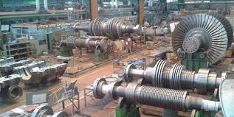

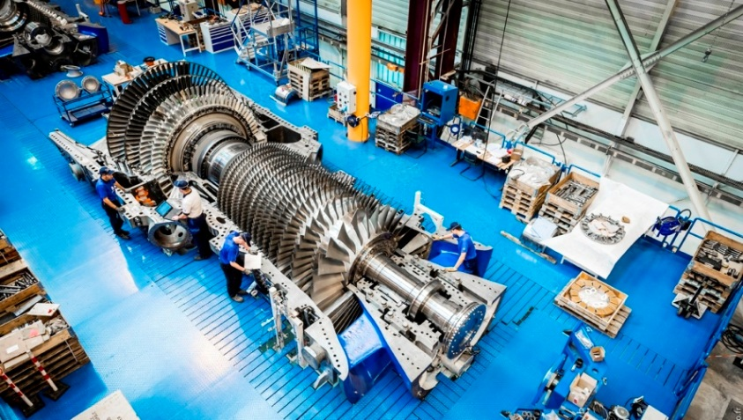

* 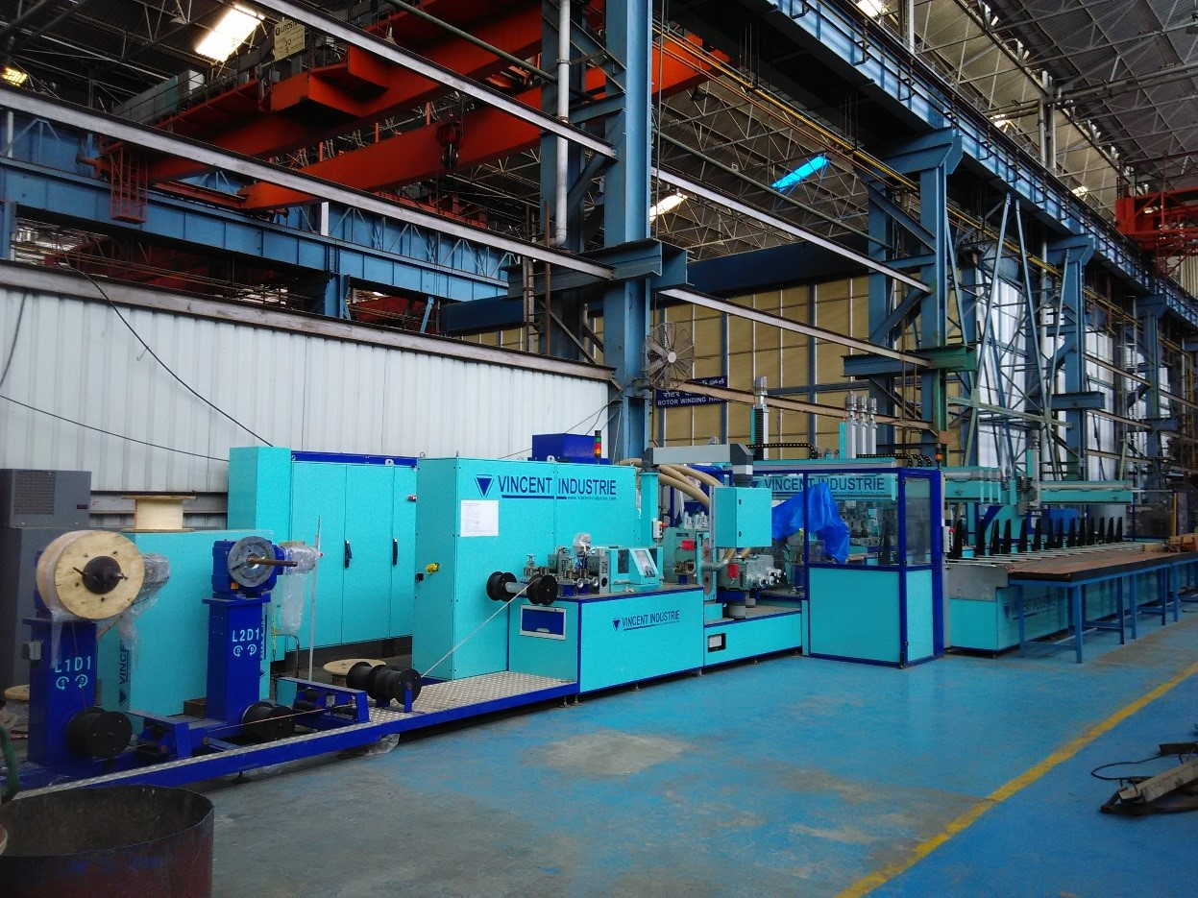
* Bearing brass
* Labyrinth Rings
* Plugs/Side stoppers
* Bearing pedestals
* Sealing rings
* Exciter frame & yoke
* Base frames
* Partitions & End Winding Covers
* Balancing plugs & weights
* Fan blades
* Rotor wedges
* Exciter poles & coils
* Exciter pedestal
* AS cover / BS cover
* Ducting & yoke supports
* Armature Shaft
* Armature core
* PMG hub & Shoes

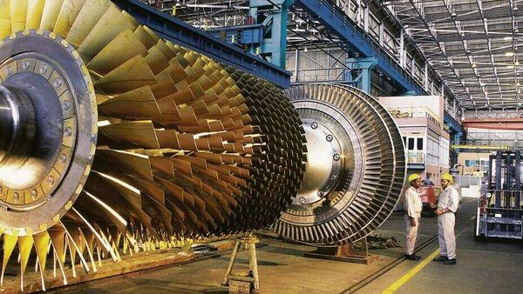

**Major operation in assembly shop** 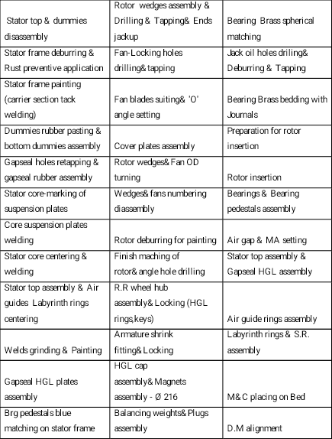

**Major activities in Assembly shop-3217 :**

* Stator top & dummies disassemble
* Stator frame deburring & Rust preventive application
* Stator frame painting (carrier section tack welding)
* Dummies rubber pasting / bottom dummies assembly
* Gap seal holes retapping & gap seal rubber assembly Stator core-making of suspension plates
* Core suspension plates welding
* Stator core centering & welding
* Stator top assembly & Air guides Labyrinth rings centering
* Welds grinding & Painting
* Gap seal HGL plates assembly
* Bearing pedestals blue matching on stator frame
* Space heaters assembly & RTD board assembly

**Operations on Rotor:**

* Rotor deburring for wedges
* Rotor wedges assembly & Drilling & Tapping & Ends jack up
* Fan-Locking holes drilling/tapping
* Fan blades suiting & ‘O’ angle setting
* Rotor wedges & Fan OD turning
* Wedges/fans numbering disassemble
* Rotor deburring for painting
* R.R. wheel hub assembly & locking
* HGL cap assembly & Magnets assembly φ 216 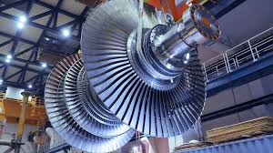
* Balancing weights & Plugs assembly
* Fan blades assembly & Angle setting & Final Locking
* Core plates assembly & Locking
* Rotor balancing
* Rotor HV test & Painting
* Preparation for rotor insertion
* Rotor insertion

**Operation on Bearings:**

* Bearing pedestal blue matching
* Bearing Brass spherical matching
* Jack oil holes drilling & Deburring & Tapping
* Bearing Brass bedding with Journals

**Operations on Test bed :**

* Test bed preparation and machine placing on bed.
* Bearings & Bearing pedestals assembly
* Air gap & MA setting
* Stator to assembly & Gap seal HGL assembly
* Air guide rings assembly
* Labyrinth rings & S.R. assembly

**STATOR WINDING(3216):**

W.C.3216 STATOR WINDING

RECEIPT OF DOCUMENTS

RECEIPT OF STATOR FROM ASSLY. W.C.3217

RECEIPT OF STATOR COILS FROM W.C.3215

E.M. PLANNNG & STORES

QUALITY CONTROL

TOOLS & GUAGES FROM SHOP TECH.

TESTING DEPARTMENT

LAYING OF STATOR BARS

WEDGING

EYE BRAING

EYE INSULATION

DESPATCH TO W.C.3215 FOR IMPREGNATION

TESTING

DESPATCH TO ASSLY. W.C.3217

IMPREGNATION OF STATOR

**STATOR WINDING TECHNICAL DETAILS:**

The three-phase stator winding is a fractional pitch two-layer type consisting of individual bars; each stator slot accommodates two bars. It is a double layer lap winding with 60o phase spread fractional Windings are used to reduce higher order harmonics and pitch of the winding is so Selected that 5th and 7th harmonics are greater reduced.

The slot bottom bars and top bars are displaced form each other by one winding pitch and connected at their ends to form coil groups. The coil groups are connected together with phase connectors inside the stator frame. This arrangement and shape of the bars at the results in a cone shaped winding having particularly favorable characteristics both in respect of its electrical properties and resistance of only one turn insulation and main insulation identical.

Stator core received after the core assembly is checked for the availability of foreign matter, so coil projections are checked in each slot.HGL drift is passed in each and every slot to detect bottom core projections. Winding holders are adopted and binding rings are assembled on both sides. The HGL binding rings are centered to the core and then bottom bars are laid. Each bar is pressed with a pressing fixture to obtain specified dimensions. By adopting this above procedure the entire bottom bars are laid in respective slots. After completing of bottom bar layer reinforcing the overhang portion by tying with nipping glass sleeve.

Temporary wedging is carried out, HV testing is done and then stiffeners are assembled. Top bars are laid by pressing each bar with a pressing fixture and all the bars are laid in respective slots. In between top and bottom bars HGL spacers are kept. And then top bars are tested.

Individual eye jointing and bracing is carried out. Then after eyes jointing individual eyes are insulated with fine mica tape. After completion of eyes jointing connector rings are assembled & connected as per drawing and three neutral and three phases terminal are terminated out. Once again HV test is carried out before sending the stator to impregnation.

**CONNECTION OF BARS:**

Brazing makes the electrical connection between the top and bottom bars. One top bars strand each is brazed to one strand of the associated bottom bar so that beginning of each strands is connected without having any electrical contact with the Remaining strands. This connection offers the advantage that circulating current losses in the stator bars are kept small. The strands are insulated from each other at the brazed joints. The coils connected are wrapped with dry mica/glass fabric tapes half overlapped. The thickness of the wrapper depends on the machine voltage. The gaps between the individual coil commendations being sufficiently large, no additional insulation is required.

**PHASE CONNECTORS:**

The phase connectors consist of flat copper sections, the cross section of which results in a low specific current loading. The connections to the stator winding are of riveted and soldered tape and are like-wise wrapped with dry mica/glass fabric tapes.The phase connectors are firmly mounted on the winding support using clamping pieces and glass fabric tapes.

**CONCLUSION:**

BHEL, India’s largest engineering and manufacturing company, is engaged in the design, engineering, manufacture, construction, testing, commissioning and servicing of a wide range of products and services for power and other core sectors of the economy. While preparing its strategic plan for the period 2012-17, BHEL had assessed (November 2011) that there would be a definite change in its business environment. BHEL acknowledged that the past decade ending 2010 had introduced challenges in the form of climate change; increase in intensity of competition with emergence of new competitors; and squeezed delivery schedules. Recognizing the challenges in the business environment, BHEL had fixed Strategic Plan targets for the period 2012-17 with a focus on diversification and innovation. The challenge before BHEL was not only to safeguard its core business, but also to focus on diversified areas like defence, solar, wind and water businesses and also involve R&D to attempt breakthrough developments. Audit noticed that the efforts for diversification and innovation were inadequate and BHEL could not make headway in any of the identified areas; - bridging technological gap in the core power sector, renovation and modernization, Indian Railway projects, solar energy etc. Research and Development initiatives also did not bring significant results. In the core power sector, an initiative towards development of Advanced Ultra Supercritical Technology for enhancing the plant efficiency and reducing coal consumption and CO2 emission did not achieve the desired outcome due to considerable delay in approval of the project.